ANSWER KEYS TO TEXTBOOK CHAPTER REVIEW EXERCISES
CHAPTER 1: WORD BUILDING RULES
A. Matching
1. g 6. i
2. f 7. a
3. b 8. j
4. e 9. d
5. h 10. k
B. Identify the Word Roots
1. cardi 6. ur
2. cyt, leuk 7. cardi
3. dermat, acr 8. dermat
4. cardi 9. cyan
5. dermat 10. card
C. What Is Wrong with This Word?
1. Correct: cardiomegaly
Rationale: A word cannot end with a combining form. The suffix -megaly should go at the end of the word.
2. Correct: leukocytopenia
Rationale: The suffix -penia should go at the end of the word. The combining vowel o should remain with the root cyt because the suffix begins with a consonant.
3. Correct: acrodermatitis
Rationale: A word cannot end with a combining form; therefore, the vowel o should be dropped and the suffix -itis should be added at the end of the word. The combining vowel is not needed because the suffix begins with a vowel.
4. Correct: gastromegaly
Rationale: The suffix -megaly should go at the end of the word. The combining vowel o should remain with the root because the suffix begins with a consonant.
5. Correct: dermatosis
Rationale: A word cannot end with a combining form; therefore, the vowel o should be dropped and the suffix -osis should be added at the end of the word. The combining vowel is not needed because the suffix begins with a vowel.
6. Correct: dysmenorrhea
Rationale: The word is in the correct order. The vowel o should be added to the root rrhea because the suffix begins with a consonant.
7. Correct: cardialgia
Rationale: The vowel o should be dropped from the root cardi and the suffix -algia should be added at the end of the word. The combining vowel is not needed because the suffix begins with a vowel.
8. Correct: dermatologist
Rationale: The suffix -logist should go at the end of the word. The combining vowel o should remain with the root because the suffix begins with a consonant.
9. Correct: cyanosis
Rationale: The suffix -osis should go at the end of the word. The combining vowel o should be dropped from the root cyan because the suffix begins with a vowel.
10. Correct: carditis
Rationale: A word cannot end with a combining form; therefore, the vowel o should be dropped and the suffix -itis should be added at the end of the word. The combining vowel is not needed because the suffix begins with a vowel.
D. Completion
1. combining form; suffix
2. word root
3. component parts
4. prefix
5. suffix
6. combining vowel
7. suffix
8. combining form
9. prefix
10. compound word
E. Review the Rules
1. c 6. d
2. a 7. b
3. c 8. a
4. a 9. b
5. a 10. a
F. Crossword Puzzle
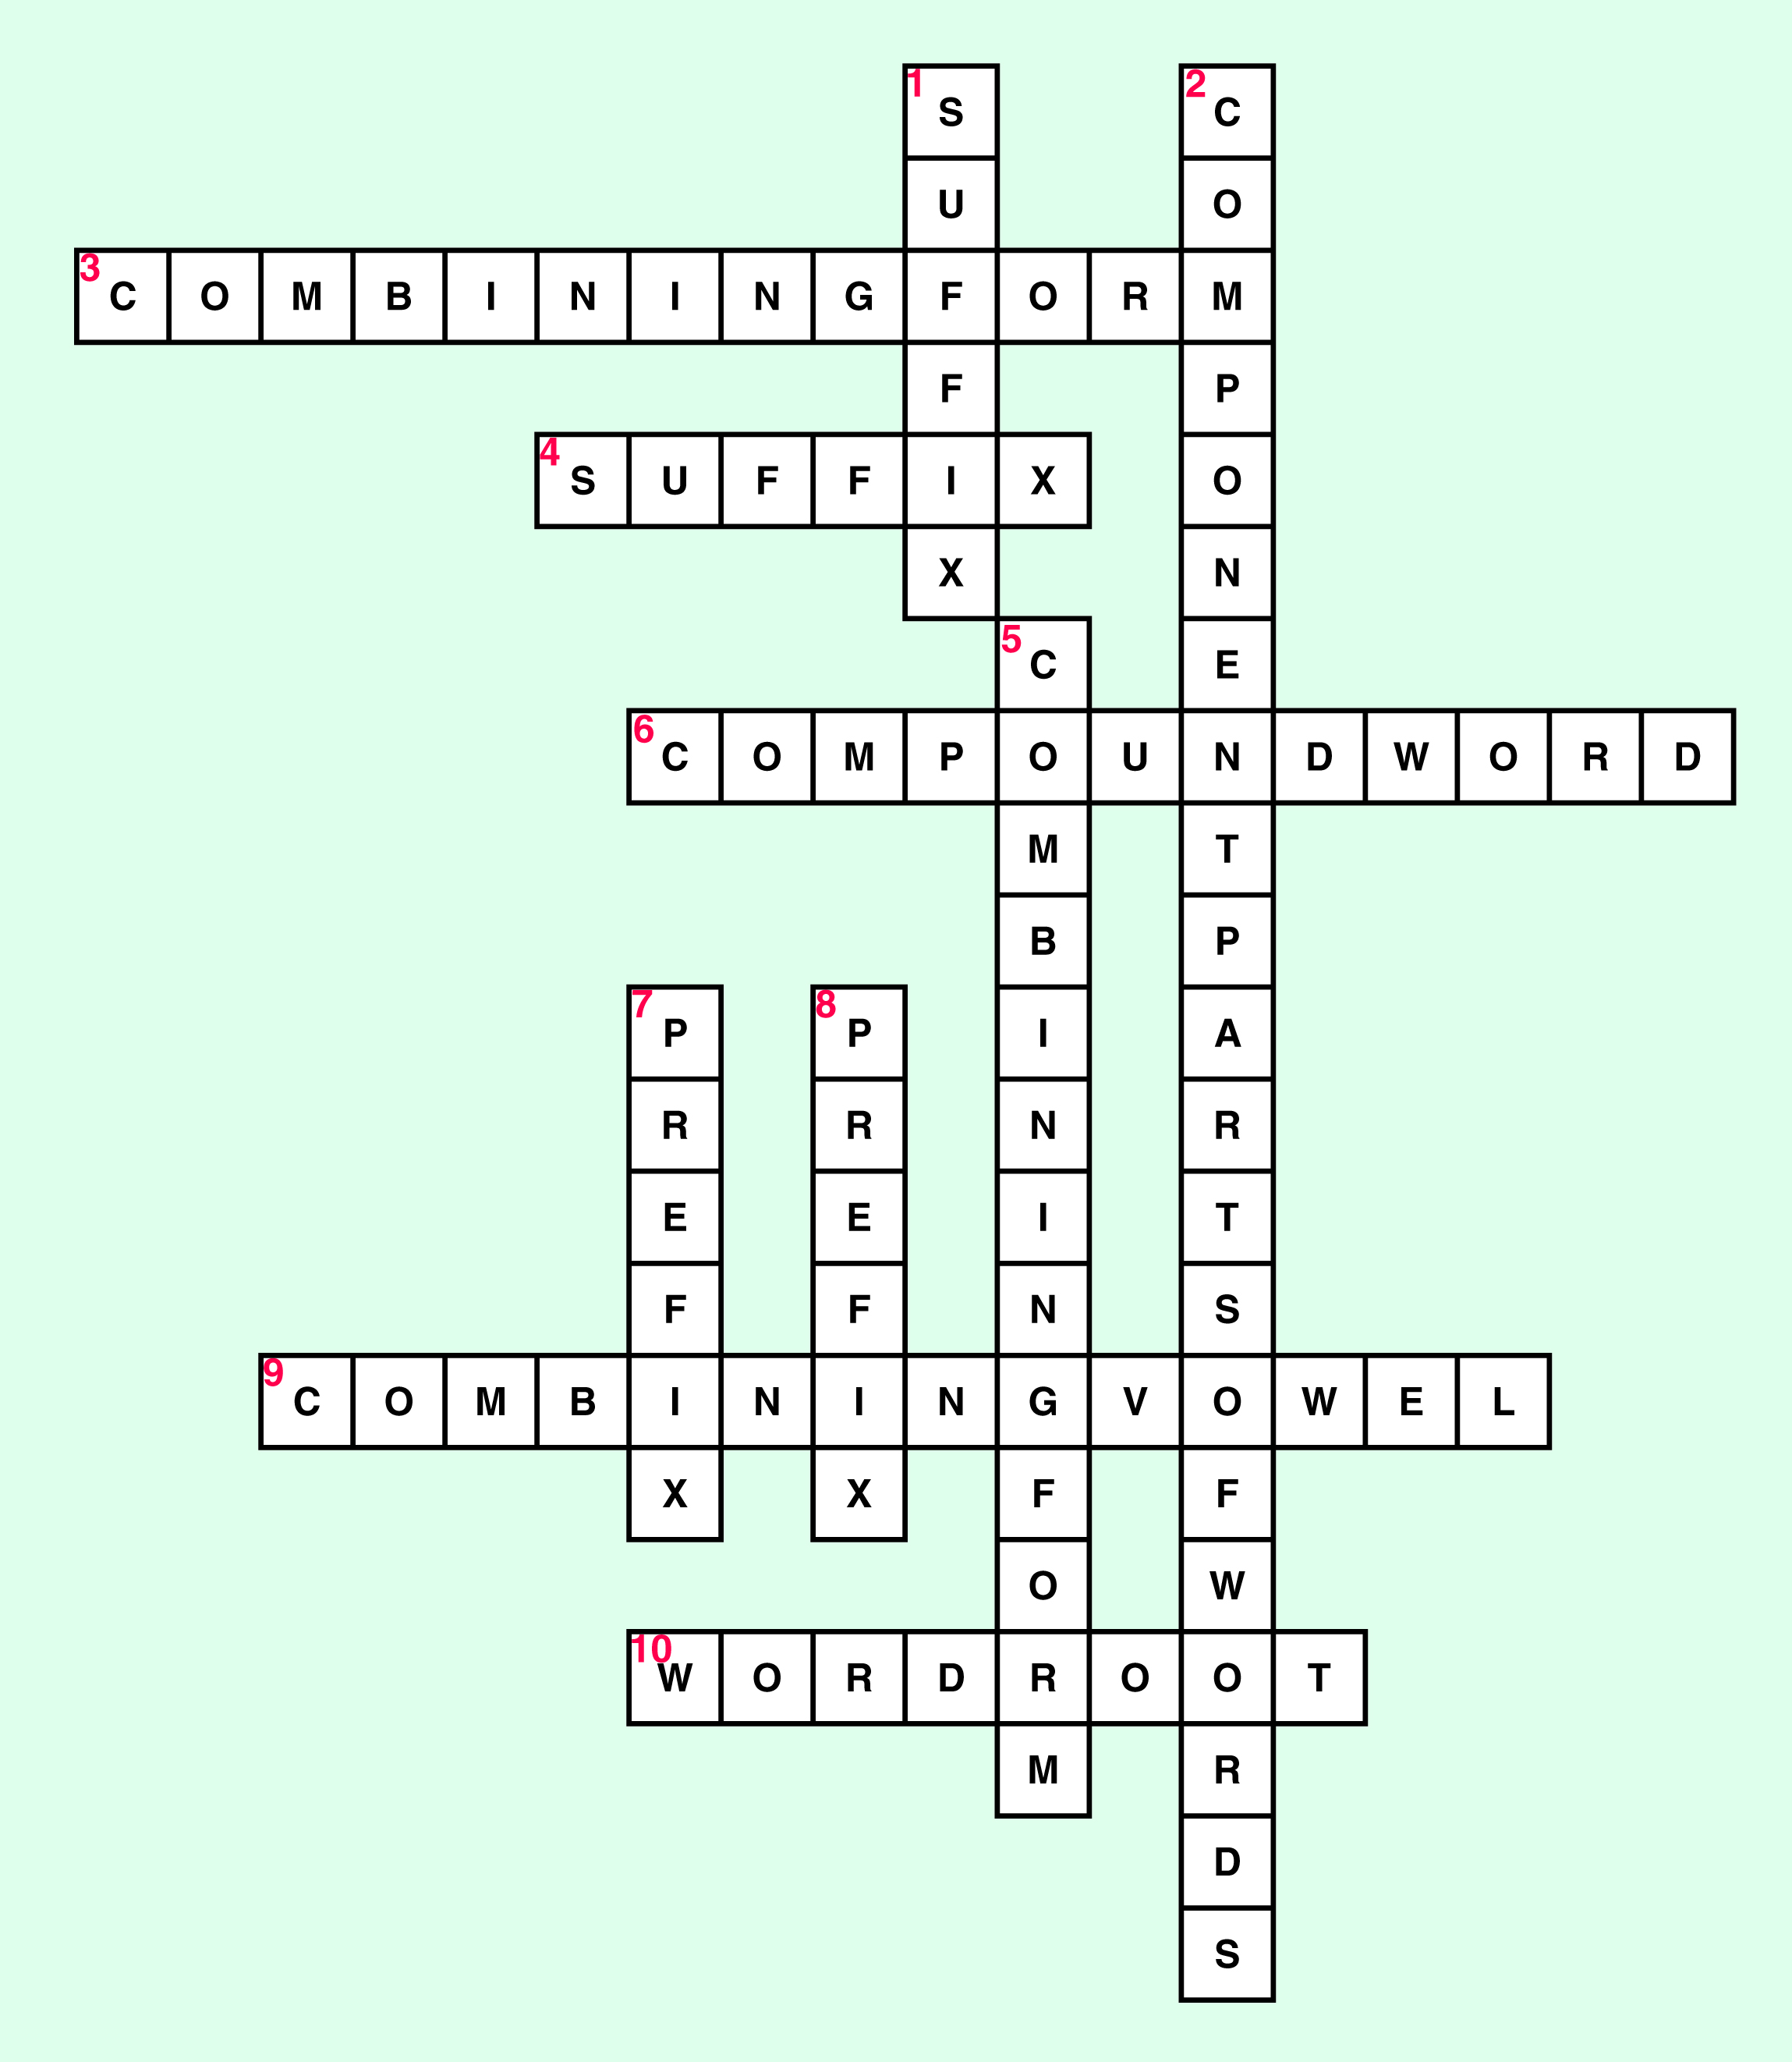

Workbook Answer Key
CHAPTER 1: Word Building Rules

Review Checkpoint
A. COMPLETION
1. the basic foundation of a word; or the foundation of a word
2. the word ending; or the ending of the word
3. word root plus a vowel
4. combining form, word root, suffix
5. o and i
6. a word element added at the beginning of the word
7. suffix
8. suffix; prefix
9. eponym
10. combining form

B. MATCHING
1. b
2. d
3. e
4. a
5. c

C. COMPLETION
1. prefix
2. suffix
3. word root
4. backward
5. suffix

D. MATCHING
1. c
2. e
3. b
4. a
5. d

ANSWER KEYS TO
CHAPTER REVIEW SHEETS
CHAPTER 2: PREFIXES
ANSWERS TO CHAPTER REVIEW SHEET 1
WORD ELEMENT TO DEFINITION
WORD ELEMENT | DEFINITION
1. a- | without, not, no
2. ab- | from, away from
3. ad- | toward, increase
4. alb- | white
5. ambi- | both, both sides
6. an- | without, not
7. ante- | before, in front
8. anti- | against
9. auto- | self
10. bi- | two, double
11. bio- | life
12. brady- | slow
13. circum- | around
14. con- | together, with
15. contra- | against
16. de- | down, from
17. dis- | free of, to undo
18. dys- | bad, difficult, painful, disordered
19. ecto- | outside
20. endo- | within, inner

CHAPTER EXAMS
Included in this section are chapter exams for Chapters 2 through 24. Chapter 2 and Chapter 3 exams consist of 50 questions: 20 multiple choice, 15 matching, and 15 completion questions. Chapters 5 through 24 exams consist of 50 questions: 20 multiple choice, 10 matching, 5 spelling, 10 completion, 5 abbreviations, and 8 extra credit points questions.

The instructor will note that examples are given for the first 10 questions of the exam in Chapter 2. The examples give a definition of a sample word with the meaning of the prefix enclosed in quotation marks. This format is designed to help the learner solidify the meaning of the prefix in the early chapters of the text. An illustration is shown below.

3. A prefix that means toward, increase (as in movement “toward” the midline of the
body) is
a. a- c. auto-
b. ad- d. bi-
Answer: ad-

If the instructor does not wish to use this format, the example can easily be eliminated from the sample test and the learner can be tested on the definition alone, without an example.
For the exam in Chapter 3, most of the multiple choice questions ask the learner to define the given suffix or to identify the suffix based upon the given definition. When a medical term is used in the question, the part that relates directly to the suffix will be in bold print since this is still new to the learner. An illustration is shown below.

9. The word that means surgical removal of the appendix is
a. appendices c. appendectomy
b. appendiceal d. appendicitis
Answer: appendectomy

Rationale: This type of question teaches the learner to see the word element as it appears in the word, locate the suffix, and define it.

EXTRA CREDIT: For those instructors who wish to provide extra credit opportunities for their students, 8 extra-credit questions have been added to each exam for Chapters 5 through 24. Each correct response is worth ¼ point for a total of two extra-credit points on the exam.
CHAPTER 2: PREFIXES
CHAPTER EXAM
MULTIPLE CHOICE
INSTRUCTIONS: The following questions or incomplete statements are followed by four answers or completions. Read each question carefully and select the most appropriate response.

1. A prefix that means without, away from (as in “without” breathing) is
a. a- c. auto-
b. ad- d. bi-
2. A prefix that means from, away from (as in wandering “away from”) is
a. ab- c. an-
b. alb- d. ante-
3. A prefix that means toward, increase (as in movement “toward” the midline of the body) is
a. a- c. auto-
b. ad- d. bi-
4. A prefix that means white (as in abnormally “white” skin) is
a. bio- c. alb-
b. auto- d. rube-
5. A prefix that means both, both sides (as in able to use “both” hands well) is
a. a- c. ante-
b. ad- d. ambi-
6. A prefix that means before, in front of (as in the space “in front of” the elbow) is
a. ambi- c. auto-
b. ante- d. brady-
7. A prefix that means against (as in a substance that works “against” the action of poison) is
a. circum- c. anti-
b. bi- d. ante-
8. A prefix that means self (as in a graft of skin transferred from one part of “one’s” body to another part) is
a. auto- c. pseudo-
b. bi- d. ambi-
9. A prefix that means two, double (as in having “two” cusps or points) is
a. auto- c. pseudo-
b. bi- d. mono-
10. A prefix that means slow (as in “slow” heartbeat) is
a. circum- c. auto-
b. ambi- d. brady-
11. The prefix circum- means
a. white c. slow
b. around d. two, double
12. The prefix con- means
a. together, with c. likeness, same
b. within d. excessive
13. The prefix dis- means
a. bad, difficult c. free of, to undo
b. outside d. outside of, beyond
14. The prefix dys- means
a. bad, difficult c. free of, to undo
b. outside d. outside of, beyond
15. The prefix ecto- means
a. good, normal c. within
b. outside d. free of, to undo
16. The prefix endo- means
a. good, normal c. within
b. outside d. free of, to undo
17. The prefix epi- means
a. half c. outside
b. same d. upon, over
18. The prefix eu- means
a. bad, difficult c. likeness, same
b. good, normal d. excessive
19. The prefix extra- means
a. outside of, beyond c. away from
b. half d. upon, over
20. The prefix homo- means
a. half c. water
b. different d. same
MATCHING
INSTRUCTIONS: Match the prefix on the left with the correct definition on the right. Enter your selection in the space provided.
_____ 21. hydro- a. beneath, under
_____ 22. hyper- b. water
_____ 23. meta- c. change, after
_____ 24. idio- d. excessive
_____ 25. infra- e. individual

_____ 26. inter- a. one
_____ 27. juxta- b. between
_____ 28. hypo- c. one-thousandth
_____ 29. milli- d. less than, under
_____ 30. mono- e. near, beside

_____ 31. multi- a. all
_____ 32. non- b. many
_____ 33. pan- c. near, beside
_____ 34. para- d. not
_____ 35. per- e. through
COMPLETION
INSTRUCTIONS: Read each statement carefully and complete the statement with the most appropriate response. Enter your answer in the space provided.

36. The prefix poly- means

37. The prefix post- means

38. The prefix pre- means

39. The prefix primi- means

40. The prefix pseudo- means

41. The prefix retro- means

42. The prefix sub- means

43. The prefix supra- means

44. The prefix that means joined, together is

45. The prefix that means rapid is

46. The prefix that means across, through is

47. The prefix that means three is

48. The prefix that means one is

49. The prefix that means dry is

50. The prefix that means around is
ANSWER KEYS TO CHAPTER EXAMS
CHAPTER 1: WORD BUILDING RULES
NO EXAM FOR THIS CHAPTER
CHAPTER 2: PREFIXES
1. a 26. b
2. a 27. e
3. b 28. d
4. c 29. c
5. d 30. a
6. b 31. b
7. c 32. d
8. a 33. a
9. b 34. c
10. d 35. e
11. b 36. many, much
12. a 37. after, behind
13. c 38. before, in front
14. a 39. first
15. b 40. false
16. c 41. backward, behind
17. d 42. under, below
18. b 43. above, over
19. a 44. sym- , syn-
20. d 45. tachy-
21. b 46. trans-
22. d 47. tri-
23. c 48. uni-, mono-
24. e 49. xero-
25. a 50. peri-, circum-
Jones/Comprehensive Medical Terminology Learning Lab Answer Key

Word Building Rules (Chapter 1)
Pretest
- Word root
- Combining form
- Suffix
- Prefix
- Eponym
- Suffix
- Combining vowel
- True
- Compound word
- True
- kn
- ps
- sk
- ch
- true

Interactive Task #1: Chalk Board
Word Components
#1
megal + o= combining form
card=word root
ia=suffix

#2
leuk + o = combining form
cyt= word root
osis = suffix

#3
Acr + o = combining form
dermat = word root
itis = suffix

#4
my/o = combining form
electr = word root
ic= suffix

#5
nas + o = combining form
pharyng = word root
itis = suffix

Interactive Task #2: Word Rules at Work
- If a suffix begins with a vowel, the word root will attach directly to it.
- The definition of a medical term begins with defining the suffix first and then working backwards through the word parts.
- If a suffix begins with a consonant, the word root will need a combining vowel before it can be added to the suffix.
- A prefix is placed at the beginning of a word.
- A compound word

Interactive Task #3: Sound Identification
- K
- Sk
- S
- S
- K
- Z
- N

Posttest
- the basic foundation of a word, to which component parts are added
- the word element that is created when a word root is combined with a vowel
- a word element attached at the end of the word root
- a word element added at the beginning of the word
- a name of a disease, organ, procedure, or body function that is derived from the name of a person who first discovered or named it
- read backward through the word and define the component parts
- consonant
- vowel
- combining form + a word root + a suffix
- prefix
- true
- true
- false
- true
- false

